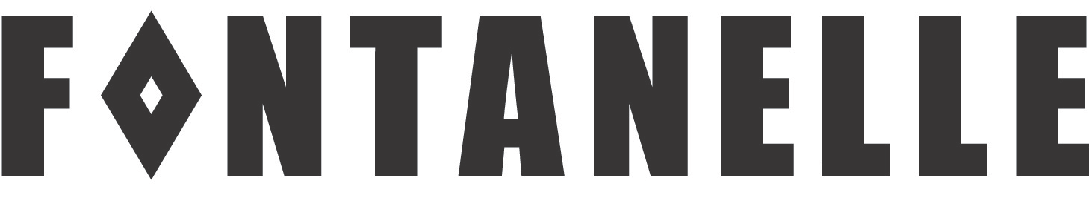
GALLERY & STUDIOS

Vote For Me

Curated by POWERHOUSE Kate Power & Brigid Noone 04/8/16 – 02/9/16

I need backup

It makes sense that this writing should be a conversation. The process of making the exhibition has been conversational and the idea of collectivity and power in numbers is conversational. We’re also proposing this idea as an open and expanding dialogue about women and representation in the arts.

It's having to remember the need to promote women’s practice, maybe that's the whole point of the project. We started the process by wanting to put on a feminist exhibition in Adelaide that would make an impact that would take up significant space in one time. We observed the nature of ARI’s as predominantly run by women and the idea of working collectively as being generous but also as a point of shared resources, support and connection. It’s about negotiation. It’s about an open and ongoing conversation and thinking through things collectively, where ideas emerge with the process of running the space and planning projects.

It’s to do with listening. The knowledge that things are formed from multiple angles with multiple influencers, it’s dynamic but it’s also a loop, its not just what you get out of it, but also what you are contributing. Maybe women working in groups can be made more powerful and more supported and more… connected. It creates critical mass- it forms a presence; you’re not trying to just get attention for something of your own. I think that’s what has felt interestingly uncomfortable about this project- the appearance that we want attention. Or maybe just the simple act of deliberately appearing. This discomfort brings up the idea of social policing and critical attitudes toward women being assertive about needing or expecting space.

Our image on the poster is such a funny abstract idea, because we aren’t trying to promote us, it’s more about the idea of promotion. We are both artists, so putting ourselves forward in that kind of a role is saying – women artists should be promoted- conceptually putting ourselves on the poster, when we aren’t actually making work for the show. It creates a nice loop, it’s asking – do you have to earn promotion? We are making this a palpable material with a sense of humour.

It’s an interesting experiment and feels like a risk, because it is uncomfortable and that’s exactly what makes the idea a reality, it’s given us a physical feeling or retort against putting yourself out there. It has made us question why appearing ‘full of yourself’ is problematic. What is the phrase ‘shameless self promotion’ about? What is the ‘shame’ part of it? Is there shame in being seen to be trying and wanting success? How do you authentically promote yourself? Can you?

I am more comfortable supporting people around me than myself, I would rather put someone else forward, and I enjoy it more. In my experience I’ve seen different generations of women feeling more comfortable with promoting other artist’s rather than themselves. Self-promotion is about branding and how people communicate. I like the idea of it being a viral feminist campaign. I’m imagining that it could link to something else that will link to something else. It’s an interesting thing to make a show that is about exposure about exposure.

How things occupy space in different ways is important. It can be loud and aggressive or a quieter approach that takes some examining, an internal space of enquiry. The exhibition shows the complexities of self-promotion and considers moments within it in different ways. It examines artist/curator relationships, contentious and deliberately intimidating spaces, internal landscapes and the promotion of embodied experience, the performance of promotion and particularly in relation to the already public observation of women, subversive humour and irony. The three spaces have quite different conversations.

And I wonder- how do we measure success? Who are we making work for? There are not clear markers to check that you’re doing well and you’re moving forward. There’s a lot of ways to check that you’re qualified. It’s not about money, there’s another currency there.

Lone hero fucking single promoter isn’t that easy for a really good reason, it doesn’t work that well for me as a woman. It’s taken ages to think we don’t need to…

That’s how we’ve been able to approach it. By you and I being a curatorial team and together promoting all these artists and their work. Which is about strengthening the existing common networks. Is it possible to have a different relationship with self-promotion? Can you consider yourself in a self-affirming way that is more about momentum and self-value? Surely self-promotion plays an important role. But maybe it’s about backing yourself. It’s about professionally committing to your future. Maybe it’s framing it differently.

It’s about demanding space as well. Being ok with taking up space. And maybe a big reason why we are in collectives and why we’re in groups with other people is because we love promoting other people. It’s really easy to do that. I’m proud of you as an artist. It’s easy to promote someone else’s work and being in a collective enables you to do that.

I feel much more comfortable embracing that. Being committed to a circular promotion. It’s important to belong and to be acknowledged. But I think I like it’s better if it’s in a relationship. Maybe it’s about partnership of promotion. How we best promote each other. Rather than trying to change ourselves to be self-promoters maybe we should embrace that this is how we do it really well. Self-promotion is not actually natural. I don’t actually need to become a self-promoting machine- I need back up.

Conversations between curatorial team POWERHOUSE: Kate Power & Brigid Noone 2016

Fontanelle Gallery & Studios/26 Sixth Street/Bowden/5007/0405 611 312
email: director@fontanelle.com.au www.fontanelle.com.au

